2021-22 Sacred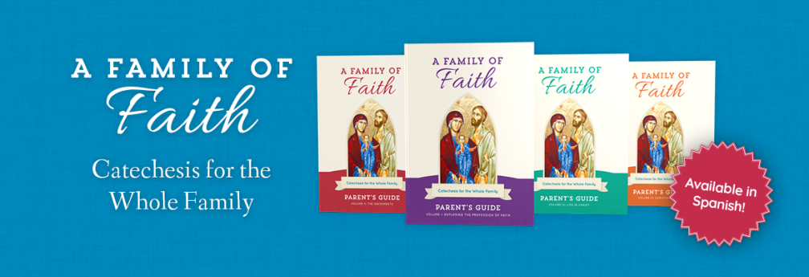 Heart Families of Faith Registration
Parental Information
Mother's Name: _______________________________________ Phone #____________________
Address:__________________________________________City__________________State_____Zip_______
Email Address: _____________________________________________________________________
Father's Name: _________________________________________ Phone #______________________
Address: _________________________________________City_______________State______Zip________
Email Address: _____________________________________________________________________
If Primary Guardian(s) is not a Parent, add information
Name(s)______________________________________________Phone #_______________________
Address: _________________________________________City_________________State____Zip________
Email Address: ____________________________________________________________________
Emergency Contact Information
Name: _______________________________________________Phone 3 __________________________
How Many students Are you registering?
1____2_____3____4____
Student Information
Student 1
Last Name__________________________ First Name_________________________________

School_________________________________ Grade Level for 2021-22 ____________________________
Check Sacraments Received: Baptism__Reconciliation__Eucharist__Confirmation__

Student 2
Last Name__________________________ First Name_________________________________

School_________________________________ Grade Level for 2021-22 ____________________________
Check Sacraments Received: Baptism__Reconciliation__Eucharist__Confirmation__

Student 3
Last Name__________________________ First Name_________________________________

School_________________________________ Grade Level for 2021-22 ____________________________
Check Sacraments Received: Baptism__Reconciliation__Eucharist__Confirmation__

Student 4
Last Name__________________________ First Name_________________________________

School_________________________________ Grade Level for 2021-22 ____________________________

Check Sacraments Received: Baptism__Reconciliation__Eucharist__Confirmation__
Please select Your first choice for class time for our Family Classes. Hopefully, we will not need a virtual class this year, but if necessary, we will add one. _____Second Sunday of the Month
_____Third Sunday of the Month
I hereby give Sacred Heart Catholic Church permission to publish picture of my child on the parish websit, social media and/or parish publications. (Please note: no names will be used. Yes___NO___
I am interested in helping as a Parent Mentor in a small group of families. Yes___ NO___
Program Costs
The fee for Families of Faith is $85.00 per family with one child and $25 for each additional child. If you register by July 15, the family fee is reduced to $75.00. Please contact Sue Vavak if financial help is needed.
Sacrament Prep will be separate from the Family formation classes, but children are required to be attending Families of Faith classes with parents in order to receive a sacrament. Reconciliation and First Communion will have a 6 week session. Confirmation Classes will meet monthly beginning in August and have 6 sessions nearer to the Confirmation date. There is a $30.00 fee for sacraments Prep costs.

