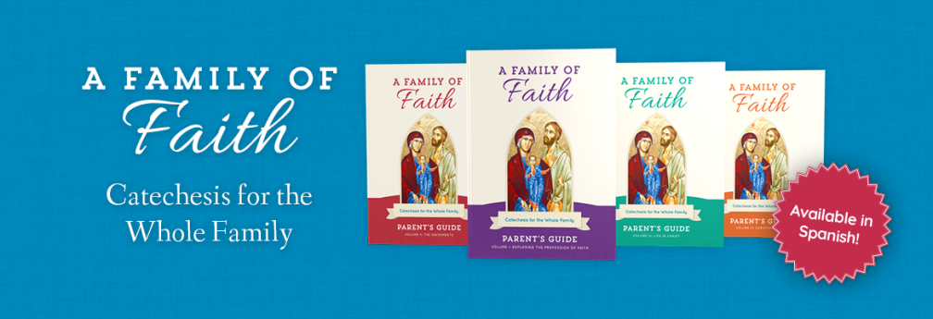
2022-23 Sacred Heart Families of Faith Registration
Parental Information
Mother's Name: _______________________________________ Phone #____________________
Address:__________________________________________City__________________State_____Zip_______
Email Address: _____________________________________________________________________
Father's Name: _________________________________________ Phone #______________________
Address: _________________________________________City_______________State______Zip________
Email Address: _____________________________________________________________________
If Primary Guardian(s) is not a Parent, add information
Name(s)______________________________________________Phone #_______________________
Address: _________________________________________City_________________State____Zip________
Email Address: ____________________________________________________________________
Emergency Contact Information
Name: _______________________________________________Phone 3 __________________________
How Many students Are you registering?
1____2_____3____4____5_____
Student Information
Student 1
Last Name__________________________ First Name_________________________________

School_________________________________ Grade Level for 2022-23 ____________________________
Check Sacraments Received: Baptism__Reconciliation__Eucharist__Confirmation__
This child is ready to prepare for the Sacrament of ________________.

Student 2
Last Name__________________________ First Name_________________________________

School_________________________________ Grade Level for 2022-23 ____________________________
Check Sacraments Received: Baptism__Reconciliation__Eucharist__Confirmation__
This child is ready to prepare for the Sacrament of ________________.

Student 3
Last Name__________________________ First Name_________________________________

School_________________________________ Grade Level for 2022-23 ____________________________
Check Sacraments Received: Baptism__Reconciliation__Eucharist__Confirmation__
This child is ready to prepare for the Sacrament of ____________________.

Student 4
Last Name__________________________ First Name_________________________________

School_________________________________ Grade Level for 2022-23 ____________________________

Check Sacraments Received: Baptism__Reconciliation__Eucharist__Confirmation__
This child is ready to prepare for the Sacrament of_____________.

This year we will meet in a large group with family groups sitting together for sharing. We will have 2 Family Classes each month on the second and third Sundays of the month, unless a holiday or holy day falls on those weeks.

I hereby give Sacred Heart Catholic Church permission to publish picture of my child on the parish websit, social media and/or parish publications. (Please note: no names will be used. Yes___NO___
I am interested in helping as a Parent Mentor in a small group of families. Yes___ NO___
Program Costs
The fee for Families of Faith is $85.00 per family with one child and $25 for each additional child. If you register by August 22, the family fee is reduced to $75.00. Please contact Sue Vavak if financial help is needed.
Sacrament Prep will be separate from the Family formation classes, but children are required to be attending Families of Faith classes with parents in order to receive a sacrament. Reconciliation and First Communion will have a 6 week session on weekends not scheduled for Family Classes. Confirmation Classes will meet monthly beginning in August and have 6 sessions nearer to the Confirmation date. There is a $30.00 fee for sacraments Prep costs (for First Communion and Confirmation).
Fees Paid______

