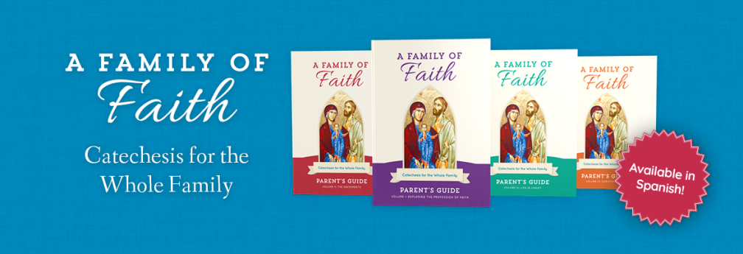
2023-24 Sacred Heart & St. Benedict the Moor Families of Faith Registration
Members of the Historic 24th Street Family of Parishes
Parental Information
Mother's Name: _______________________(Maiden)____________________ Phone #__________________
Address:__________________________________________City__________________State_____Zip_______
Email Address: _____________________________________________________________________
Father's Name: _________________________________________ Phone #______________________
Address: _________________________________________City_______________State______Zip________
Email Address: _____________________________________________________________________
If Primary Guardian(s) is not a Parent, add information
Name(s)______________________________________________Phone #_______________________
Address: _________________________________________City_________________State____Zip________
Email Address: ____________________________________________________________________
Emergency Contact Information
Name: _______________________________________________Phone 3 __________________________
How Many students Are you registering?
1____2_____3____4____5_____ Other #______
Student Information
Student 1
Last Name__________________________ First Name_________________________________
School____________________________ Grade Level for 2022-23 __________Birth Date_________________
Check Sacraments Received: Baptism__Reconciliation__Eucharist__Confirmation__
This child is ready to prepare for the Sacrament of ________________.
Any Food Allergies Medical Information of Learning needs?

Student 2
Last Name__________________________ First Name_________________________________
School____________________________Grade Level for 2022-23 _____ birth Date______________
Check Sacraments Received: Baptism__Reconciliation__Eucharist__Confirmation__
This child is ready to prepare for the Sacrament of ________________.
Any Food Allergies Medical Information of Learning needs?

Student 3
Last Name__________________________ First Name_________________________________
School_____________________________ Grade Level for 2022-23 ______Birth Date______________
Check Sacraments Received: Baptism__Reconciliation__Eucharist__Confirmation__
This child is ready to prepare for the Sacrament of ____________________.
Any Food Allergies Medical Information of Learning needs?

Student 4
Last Name__________________________ First Name_________________________________
School______________________________ Grade Level for 2022-23 _____Birth Date_______________

Check Sacraments Received: Baptism__Reconciliation__Eucharist__Confirmation__
This child is ready to prepare for the Sacrament of_____________.
Any Food Allergies Medical Information of Learning needs?

This year we will meet in a large group with breakout centers. We will have 1 Family Class each month on the second Sunday of the month, unless a holiday or holy day falls on those weeks.

I hereby give Sacred Heart Catholic Church permission to publish picture of my child on the parish website, social media and/or parish publications. (Please note: no names will be used. Yes___No___
I am interested in helping as a Parent Mentor in a small group of families. Yes___ NO___
Program Costs: The fee for Families of Faith is $75.00 per family. Sacrament Prep Classes will be separate from the Family Formation Classes, but children are required to be attending Families of Faith classes with parents in order to receive a sacrament. There is a $30.00 fee for sacraments Prep costs (for First Communion and Confirmation). Reconciliation and First Communion will have a 6 week session on weekends not scheduled for Family Classes. Confirmation Classes will meet monthly beginning in August and have 6 sessions nearer to the Confirmation date.
We have scholarships available, so please call Sue Vavak at 402-451-5755 for more information.
I understand that at least one parent must attend classes with their child(ren) or have a trusted adult come with your child(ren). Parents are the most important teachers of faith for their children. Together we will share faith, pray together and grow closer to Jesus.
Signed _____________________________ Fees Paid______

